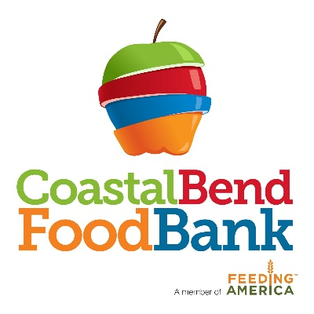

Immediate Job Opening

Job Title: Product Recovery Inspector

Job Duties: The primary responsibilities of this position are:
- Ensure maximum utilization, proper handling, and inspection of donated product.
- Mark, sort, and box all recovered product
- Keep accurate log entries of donated product
- Assist inventory manager with inventory control
- Assist in providing training and supervision of volunteers
- Comply with all health regulations regarding food handling
- Operate forklifts, electric and manual pallet jacks, and other warehouse equipment.

Qualifications: High school diploma or equivalent. Ability to read, write and speak English. Ability to count, add, subtract, multiply, and divide with comprehension. Must have flexible work availability including mornings, evenings and Saturdays.

Rate of Pay: $9/hour

Job Closing Date: Wednesday September 27, 2017

Please complete an application and submit to Martha Cabrera, HR Generalist at 826 Krill Street, Corpus Christi, TX 78408.

