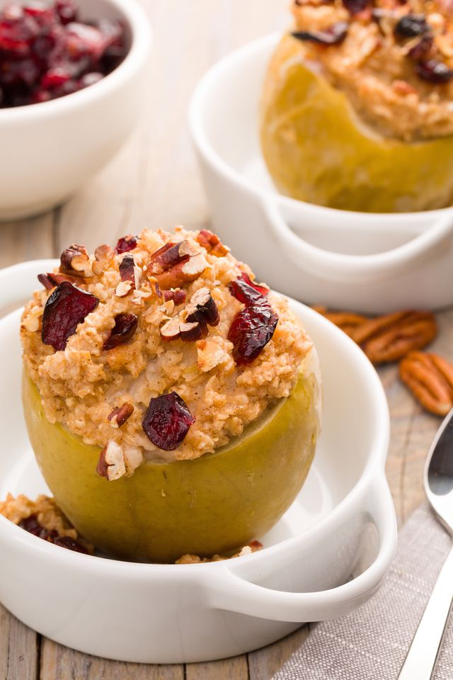
Breakfast Baked Apples

Yield: 4
Prep time: 45 Minutes

Ingredients
- 2 cups old fashioned rolled oats
- 3 cups water
- 2 tablespoons maple syrup
- 1 tablespoon cinnamon
- 4 large apples, tops sliced and insides hollowed
- 2 tablespoons dried cranberries
- 2 tablespoons chopped pecans

Directions

Step 1
Preheat oven to 400° . In a medium saucepan over medium-low heat, combine oatmeal and water and stir occasionally until creamy. Stir in maple syrup and ground cinnamon and let cool slightly.

Step 2
Transfer Apples to a glass baking dish and spoon in oatmeal. Bake until apples are soft and bubbly, about 35 minutes.

Step 3
Top oatmeal with cranberries and pecans and serve.

