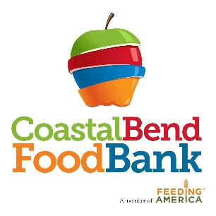

Immediate Job Opening

Job Title: Driver - Class A Commercial Driver’s License

Job Duties: The primary responsibilities of this position are to provide dependable, timely and efficient transportation of product from donors to the Food Bank, make deliveries of product to agencies and Mobile Pantry clients, and to provide dependable assistance in warehouse operations and safety procedures.

Qualifications:
- Minimum high school diploma or equivalent.
- CDL class A license.
- Three years of verifiable current CDL driving experience.
- The ability to speak, read, write, and comprehend English.
- The ability to count, add, subtract, multiply and divide with comprehension.
- The ability to do heavy lifting (up to 80 pounds) safely, reach high and low, full range of motion of upper and lower extremities.
- Forklift, electric/manual pallet jack, and warehouse experience required.
- Ability to drive both standard and automatic transmission.
- Ability to work flexible schedule including Saturdays and evenings.

Rate of Pay: $17.50/hr

Job Closing Date: Until filled

Please complete an application and submit to Martha Cabrera, H.R. Generalist at 826 Krill Street, Corpus Christi, TX 78408 or email to mcabrera@coastalbendfoodbank.org

