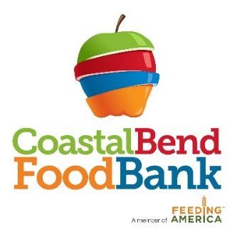

Immediate Job Opening

Job Title: Product Recovery Inspector

Job Summary: The primary responsibilities of this position are to ensure maximum utilization and proper handling and inspection of donated product and to provide training and supervision of volunteers.

Job Duties:
- Receive and inspect perishable/salvage product
- Assess the condition of donations, placing acceptable products in proper storage and immediately discarding all unacceptable products
- Keep accurate log entries of all donations
- Mark, sort and box all recovered product
- Supervise and train all volunteers assisting with product inspections
- Follow procedures pertaining to proper handling of inventory temperatures
- Maintain first in/first out inventory control
- Report any spoilage or disposal of inventory to the Inventory Coordinator
- Submit required reports and information to the Inventory Coordinator and Management
- Operate forklifts, electric and manual pallet jacks and other warehouse equipment
- Conduct periodic physical inventories as directed
- Assist with the maintenance and cleaning of the warehouse and equipment
- Comply with all health regulations and other laws that govern food handling

Qualifications:
- High school diploma or equivalent.
- 1 year of experience operating a pallet jack and food handling/inspection.
- Ability to read, write and speak English.
- Ability to count, add, subtract, multiply, and divide with comprehension.
- Must have flexible availability to include Saturdays.

Rate of Pay: $11.50/hour

Job Closing Date: until filled

Please complete an application and submit to Martha Cabrera, HR Generalist at 826 Krill Street, Corpus Christi, TX 78408 or email to mcabrera@coastalbendfoodbank.org

