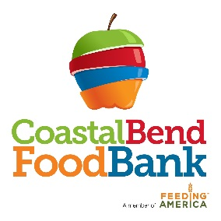

Immediate Job Opening

Job Title: Receiver

Job Duties: The primary responsibilities of this position are to oversee the receiving area, receive, inspect, identify, count and verify quality and labeling of all product delivered to the Food Bank, as well as complete related documentation, coordinate the proper storage of product in the warehouse, cooler or freezer and enter information into an inventory database.

Qualifications:
- High school diploma or equivalent.
- Minimum 2 years receiving experience
- Intermediate computer skills
- Ability to keep accurate records of incoming/outgoing loads.
- Ability to lift up to 50 lbs.
- Forklift/pallet jack experience

Rate of Pay: $13.00/hr

Job Closing Date: until filled

Please complete an application and submit to Martha Cabrera, HR Generalist, at 826 Krill Street, Corpus Christi, TX 78408 or email to mcabrera@coastalbendfoodbank.org

