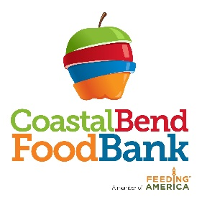
Immediate Job Opening

Job Title: Warehouse Clerk- Full time

General Description: The primary responsibilities of this position are to provide dependable assistance in the warehouse operations and safety procedures, particularly in the areas of product receipt and distribution.

Job Duties: Fill agency orders, coordinate loading of agency vehicles, handle inventory receipts and picking lists, rotation of product, maintain warehouse in a neat orderly state, assist with receiving and distribution of inventory.

Qualifications:
- High school diploma or equivalent.
- Minimum 1 year warehouse experience
- Minimum 1 year Current Forklift experience
- Minimum 1 year pallet jack experience
- Ability to lift up to 80 lbs.
- Ability to read, write and understand English
- Understand basic math calculations
- Ability to work in extreme temperatures
- Ability to work a flexible schedule to include Saturdays

Rate of Pay: $11.50/hour

Job Closing Date: until filled

Please complete an application and submit to Martha Cabrera, HR Generalist at 826 Krill Street, Corpus Christi, TX 78408 or email to mcabrera@coastalbendfoodbank.org

