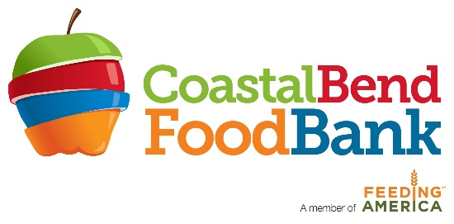
FOR IMMEDIATE RELEASE: April 11, 2022
Micaela Calderon-Stewart
Coastal Bend Food Bank
361-887-6291 ext. 5101
mcalderon@coastalbendfoodbank.org

MEDIA RELEASE

The Coastal Bend Food Bank ANNOUNCES the Groundbreaking Ceremony for our new building

Corpus Christi, Texas: After much anticipation the Coastal Bend Food Bank (CBFB) is proud to announce the Groundbreaking Ceremony of our new building, on Wednesday, April 13, 2022, at 1:30pm at the future site of CBFB located at 5442 Bear Lane, Corpus Christi, Texas.

CBFB first announced the NEW Building Campaign in June 2021 during a special ceremony and announcement of our first major donation from Valero Refinery towards construction.

“Breaking ground on our new Food Bank building is a historical event.” said CBFB Executive Director, Bea Hanson “For the past 40 years, we have operated out of a 1600 SF warehouse. 60% of our dry products are in outside storage. The new 108,000 SF building will help meet the nutritional needs of Coastal Bend and South Texas residents through fair weather and disasters for many years to come.”

The groundbreaking event will feature Coastal Bend Food Bank Board of Directors, CBFB Operations Manager, James Burnett and Executive Director, Bea Hanson sporting hard hats and shovels in hand to kick-off construction for the future Coastal Bend Food Bank.
Guest speakers will include CBFB Board President, Dr. Carol Houston and West Oso ISD Superintendent, Conrado Garcia. Along with a special presentation with Abigail & Julia Humes, CBFB Ambassadors and West Oso ISD students as they “Unpack the Future.”

